Title: **Basic Instructions** Handout: 1

Course: Introduction to Automation Unit: Introduction of PLC CLO: 4

**Objectives**

1. Student shall develop a knowledge of the Examine if Closed (XIC) test instruction.
2. Student shall develop a knowledge of the Examine if Open (XIO) test instruction.
3. Student shall develop a knowledge of the Output Energize (OTE) output instruction.

**Theory**

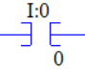Examine if Closed (XIC)

This test instruction can also be called "examine on" or “test for 1“. If the assigned address is true, the instruction will have logical continuity. If the assigned address is false, the instruction will not have logical continuity. Addresses assigned to this instruction must be specified to the bit level (I:0/0).

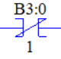Examine if Closed (XIC)

This test instruction can also be called "examine off" or “test for 0“. If the assigned address is false, the instruction will have logical continuity. If the assigned address is true, the instruction will not have logical continuity. Addresses assigned to this instruction must be specified to the bit level (B3:0/1).

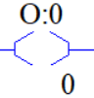Output Energize (OTE)

This output instruction sets the specified address bit to the value of its rungs continuity. If the rung obtains continuity the address will be set to true. If the rung loses continuity, the address shall be reset false. Output addresses are written to the output table and directly to the output channel. All outputs shall be driven after all logic rungs have been evaluated. For best programming results, an output address should be written to once within the program. Output addresses are specified to the bit level. (O:0/0)

**Graphics**

|  |  |  |
| --- | --- | --- |
| XIC | XIO | OTE |
|  |  |  |

**Devices**

|  |  |  |
| --- | --- | --- |
| Inputs | | |
| *Device* | *Description* | *Symbol* |
| NC Pushbutton (PB1) | Reset Counter | CNT_RST |
| NO Pushbutton (PB2) | Count Up | CNT_UP |
| NO Pushbutton (PB3) | Count Down | CNT_DW |
| Outputs | | |
| *Device* | *Description* | *Symbol* |
| Green Pilot Light | Count Up Enabled | CTU_EN |
| Yellow Pilot Light | Count Down Enabled | CTD_EN |
| Red Pilot Light | Count Done | CNT_DN |
| Blue Pilot Light | Count Under/Overflow | UN_OV |

**Instructions**

Program the logic should below.

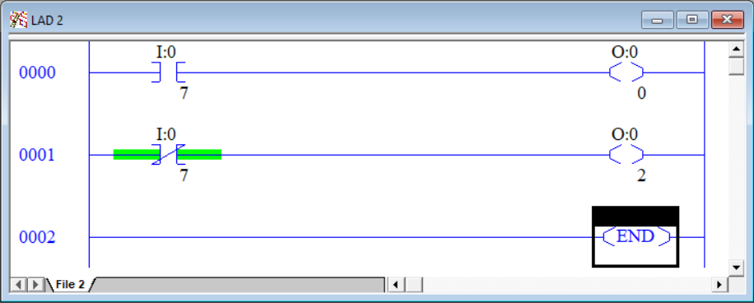

1. Download the program and observe the logic online.
2. Notice that the red light is on. The Examine if Open has logical continuity since that is a normally open pushbutton that is in fact open. One may also think of this instruction as a “Test for 0” and since there is 0V at that input channel, the instruction is giving a true result. Notice the instruction is highlighted green. Any instruction that is evaluating to true will highlight green. If an instruction is not highlighted, it is resulting in a logical false.
3. Press and hold PB2. Notice that the green light comes on and the red light goes off. In the problem the Examine if Closed instruction is highlighted green since the normally open pushbutton is in fact close. One may also tink of this instruction as a “Examine if True” and since the pushbutton contacts are close and sending the source voltage to in input channel, the PLC store a 1 (true) in that address location. Also notice that the Examine if Open instruction is no longer highlight since the pushbutton contacts are no longer open.
4. Release PB2 and observe the green light shall go out and the red light shall turn on. Notice the Output Energize in rung 0001 is highlighted green. This indicates that rung 0002 has logical continuity at will set that output address to true. A true output means the output contacts will close sending source voltage out to the final control element.

Program the logic should below.

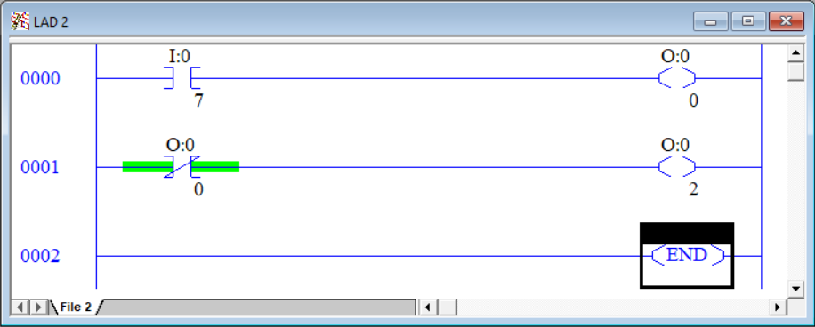

1. Either the Examine if Closed or the Examine if Open can test not only input addresses, but any bit level address. Here, rung 0001 uses an output address with an Examine if Open instruction. This program should behave the same as the previous program.
2. Press and hold PB2. Observe the red light turns off and the green light turns on. Notice the highlighting in the online program.
3. Release PB2. The red light illuminates, and the green light turn off.

Program the logic should below.

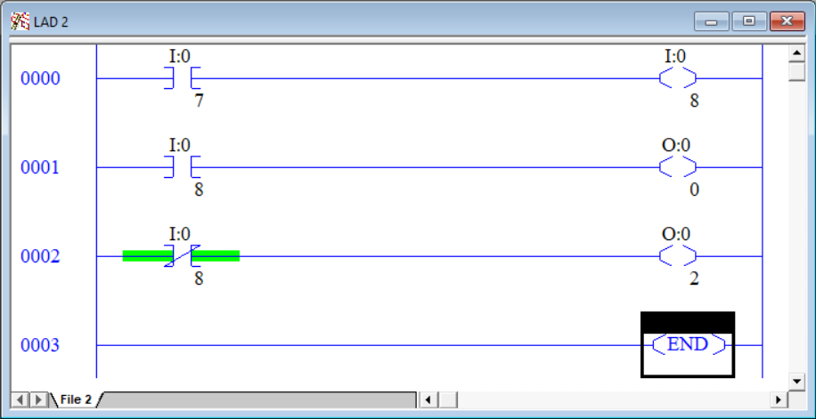

1. Notice that the Output Energize instruction is writing to a input address. This is allowable and sometimes necessary to do within a program. Since PB2 is not pressed, the red light is on and the green light is off.
2. Press and hold PB2 and observe the online program. Notice that the rung 0000 Examine if Closed instruction has logical continuity and is highlighted green. Since rung 0000 has continuity, a 1 is written into I:0/8 even though that button is not being pressed.
3. Rung 0001 tests I:0/8 for a 1, which it now has, and energized the output O:0/0.
4. Rung 0002 tests I:0/8 for a 0, which fails, and de-energizes the output O:0/2.
5. Release PB2.
6. Press PB3. Nothing happens. That’s because after all the inputs are read, the ladder logic is evaluated and in rung 0001, whatever was stored in I:0/8 is overwritten with the result of that rung.
7. Writing to inputs is an advanced practice that should only be used by experienced PLC programmers. This exercise was conducted so the student could observe the pitfalls of doing such tactics.

This page left intentionally almost blank